Exercice 5.1.1
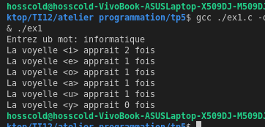
#include <stdio.h>
#include <string.h>
void main(){
char ch[50];
int i;
int e;
int o;
int a;
int u;
int y;
int j;
i=0;
e=0;
o=0;
a=0;
u=0;
y=0;
j=0;
printf("Entrez ub mot: ");
scanf("%s",ch);
for (j = 0; j <= strlen(ch)-1; j++){
switch (ch[j]){
case 'e':
e++;
break;
case 'i':
i++;
break;
case 'o':
o++;
break;
case 'a':
a++;
break;
case 'u':
u++;
break;
default:
break;
}
}
printf("La voyelle <i> apprait %d fois \n",i);
printf("La voyelle <e> apprait %d fois \n",e);
printf("La voyelle <o> apprait %d fois \n",o);
printf("La voyelle <a> apprait %d fois \n",a);
printf("La voyelle <u> apprait %d fois \n",u);
printf("La voyelle <y> apprait %d fois \n",y);
}

Exercice 5.1.2
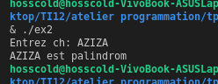
#include <stdio.h>
#include <string.h>
void main(){
char ch[50];
int i;
printf("Entrez ch: ");
scanf("%s",ch);
i=0;
while (ch[i]==ch[strlen(ch)-i-1] && i<(strlen(ch)-1)/2)
{
i++;
}
ch[i]==ch[strlen(ch)-i-1] ? printf("%s est palindrom \n",ch) : printf("non palinfrome \n");
}

Exercice 5.1.3
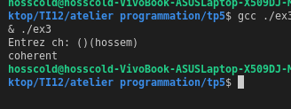
#include <stdio.h>
#include <string.h>
void main(){
char ch[50];
int i,ma7loul,msaker;
printf("Entrez ch: ");
scanf("%s",ch);
ma7loul=0;
msaker=0;
for(i=0;i<=(strlen(ch)-1);i++){
switch (ch[i])
{
case '(':
ma7loul++;
break;
case ')':
msaker++;
break;
default:
break;
}
}
ma7loul == msaker ? printf("coherent \n") : printf("ne pas coherent \n");
}

Exercice 5.2.1
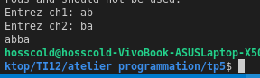
#include <stdio.h>
#include <stdlib.h>
#include <string.h>
void main(){
char ch1[50];
char ch2[50];

printf("Entrez ch1: ");
gets(ch1);
printf("Entrez ch2: ");
gets(ch2);

if(strcmp(ch1,ch2) == 1){
strcat(ch2,ch1);
puts(ch2);
} else {
strcat(ch1,ch2);
puts(ch1);
}

}

Exercice 5.2.2
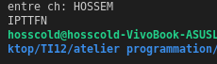
#include <stdio.h>
#include <stdlib.h>
#include <string.h>
void main(){
char ch[50];
char ch1[] = "ABCDEFGHIJKLMNOPQRSTUVWXYZ";
int x,j;
printf("entre ch: ");
scanf("%s",ch);
for (int i = 0; i < strlen(ch); i++){
j=-1;
do {
j++;
}while(ch[i] != ch1[j]);
ch[i]=ch1[j+1];
}
printf("%s \n",ch);
}

Exercice 5.3.1
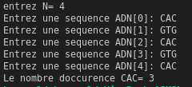

#include <stdio.h>
#include <string.h>
void main(){
char adn[9][4] = {"GTG","CAC","CTG","ACT", "CCT","GAG", "AGG","TCT","GCC"};
char t[50][4];
char ch1,ch2;
int n,i,j,ok,occ;
printf("entrez N= ");
scanf("%d",&n);
for (i = 0; i <= n; i++){
ok=0;
do {
printf("Entrez une sequence ADN[%d]: ",i);

scanf("%s",t[i]);
j=0;
do{
//printf("%s==%s %d\n",t[i],adn[j],strcmp(t[i],adn[j]));
if(strcmp(t[i],adn[j])==0) {
ok=1;
} else {
j++;
}
}while(ok == 0 && j<9);
}while(ok==0);
}
//nombre d'occurence
occ=0;
for (int j = 0; j <= i; j++){
if(!strcmp(t[j],"CAC"))
occ++;
}
printf("Le nombre doccurence CAC= %d \n",occ);
}

